1. 
2. There are two situations such as
   1. Duplicating the Code.
   2. Component needing data from the data storage.
3. 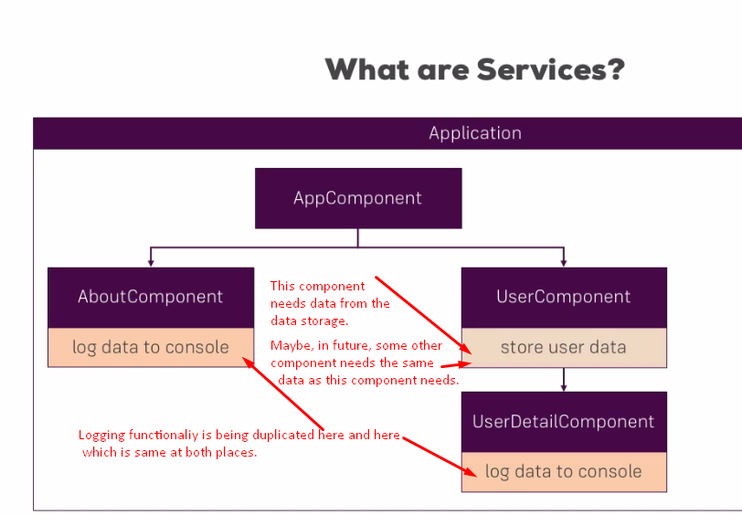
4. Service acts as central repository or central business unit in angular app where you can **centralize** your code.
5. 